**Damage Detection**

Table of Contents

* Business Problem
* Deep Learning Approach Solution
* Architecture of Model
* Advance Work: Based on mask RCNN
* Results
* References

**Business Problem**

While the transportation of vehicles, there is a possibility that the vehicle gets some amount of damage in the logistics process. This may lead to revenue loss as the vehicle is not accepted by the client and is sent back. Thus it is very important to find out the location of the damage before it reaches the client. This will save a lot of revenue and transportation cost.

**Deep Learning Approach Solution**

One way to handle this issue is using Computer vision techniques, Frequent manual inspections are not feasible. Using Computer vision and Deep learning we can identify the damage(dents, scratches, broken parts ) of the vehicle automatically and can trace back where the damage occurred during the transportation.

We created a simple image classifier that classifies the image of a vehicle or a part of a car and predicts whether the vehicle is damaged or not. We used a Convolution Neural Network Architecture for making the classifier. To improve the process of training we used Transfer learning, which means we used a pre-trained model with some custom changes and trained the model.

**Architecture of Model**

As mentioned earlier we used transfer learning to improve the learning process of the model. The model we used is inception v3 model with weights initialized as per imagnet weights. The top layer of the model was customized as we wanted the output to be a classifier i.e a gives 0 or 1 as output. The weights of the top layer are needed to be learned by the training process. However, the bottom layer which has weights initialized as imagnet weights need no training as they are optimized already.

**Advance Work**

The classifier is based on a very simple task i.e to determine whether the vehicle is damaged or not. However, we need some more details like the severity of damage, the area which is affected and many more factors. To get these parameters a simple image classification model won’t give these details. Thus we use something known as image segmentation. This means in a given image the segmentation algorithm will divide the image into some parts which are the components of the image. A demo image is shown below.

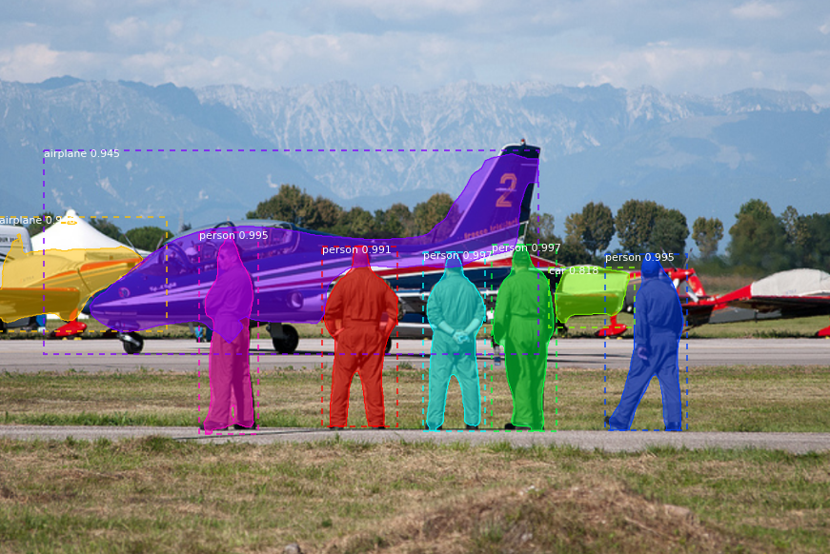

* Mask RCNN is one of the technologies used for this purpose. To know more about this , refer the reference unit of the article.
* Other technology which could be used is object detection where we detection where the damage occurred as well as classify the damage as dent, scratch, crack etc

We have used the Mask RCNN model for the detection and segmentation of the deranged area of the vehicle. We made a demo based on a custom dataset of cars where we detected the location of damage as well as the area that affected damage, we can also classify the type of damage like scratch, dent etc. See the images below for reference :

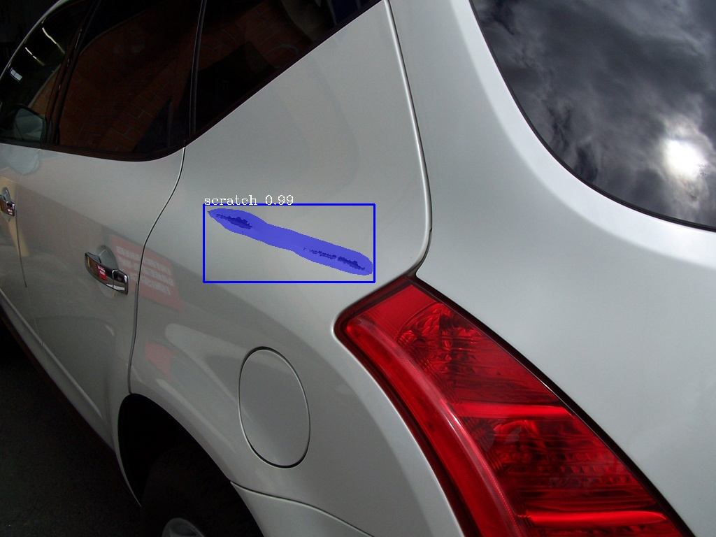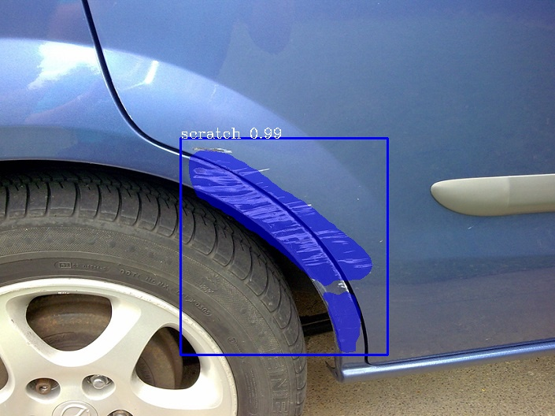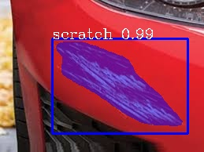

We used the pre-trained model of Mask RCNN on COCO dataset and trained it on the custom dataset using a library known as pixellib.

**Results**

Using the simple classification method we got around 92% of accuracy in the classification of image. We trained the model for around 500 epochs on various images.

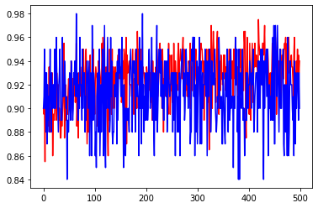

Graph of epochs vs accuracy

**References**

Inceptionv3 :<https://paperswithcode.com/method/inception-v3>

Mask CNN : <https://arxiv.org/abs/1703.06870>

Object Detection : <https://arxiv.org/pdf/1807.05511.pdf>

COCO mask RCNN : https://github.com/matterport/Mask_RCNN